**Front-End UI/UX Mini Project**

**1. Title Page**

* **Project Title**: *“NGO awareness website”*
* **Submitted By**: 
  + *ANJANA BINU*

*Rg no-2463007*

*Gmail- anjana.binu@btech.christuniversity.in*

* + *ASWATHI V*

*Rg no-2463010*

*Gmail [-aswathi.v@btech.christuniversity.in](mailto:-aswathi.v@btech.christuniversity.in)*

* + *YADU NANDAN*

*Rg no-2463067*

*Gmail- yadu.nandan@btech.christuniversity.in*

* **Course**:  *UI/UX Design Fundamentals*
* **Instructor Name**: *DR.Dheeraj*
* **Institution**:  *Christ University*
* **Date of Submission**: *10/08/2025*

**2. Abstract**

*This project aims to design and develop two responsive websites — an NGO Awareness site— using only HTML and CSS. The NGO site highlights the organization’s mission, causes, and contact details, The focus was on clean design, easy navigation, and visually appealing layouts for effective communication*.

**3. Objectives**

* *Clearly list the project goals:*
* *Design attractive and user-friendly interfaces for both the NGO Awareness website and*
* *Develop fully responsive layouts using only HTML and CSS.*
* *Implement structured HTML5 semantic elements for better readability and SEO.*
* *Apply CSS styling to create appealing branding, layout, and responsive behavior.*
* *Ensure accessibility, clear navigation, and consistent performance across devices.*

**4. Scope of the Project**

* *Focused entirely on front-end design for the NGO Awareness website*
* *No JavaScript functionality or server-side integration was implemented.*
* *Designed and optimized for desktop, tablet, and mobile viewports to ensure responsiveness.*
* *Developed using only open-source tools and pure HTML/CSS code without external libraries.*

**5. Tools & Technologies Used**

|  |  |
| --- | --- |
| Tool/Technology | Purpose |
| HTML5 | Markup and content structure |
| CSS3 | Styling and layout management |
| VS Code | Code editor |
| Chrome DevTools | Testing and debugging |

**6. HTML Structure Overview**

* Used semantic tags: <header>, <nav>, <main>, <section>, <footer>
* Structured into reusable sections: About, Projects, Contact
* Navigation menu using <ul> and anchor links for smooth scrolling

**7. CSS Styling Strategy**

* Used external CSS file (style.css)
* Organized with comments and sections
* Techniques used:
  + Flexbox and Grid for layout
  + Media Queries for responsiveness
  + CSS Variables for theme customization
  + Hover effects and transitions
  + Mobile-first design approach

**8. Key Features**

|  |  |
| --- | --- |
| Feature | Description |
| Responsive Design | Adapts seamlessly to all screen sizes |
| Smooth Navigation | Fixed top nav with anchor links |
| Project Cards | Flex-based layout with hover effects |
| Contact Form (non-functional) | Placeholder layout for inputs and button |
| Accessible Fonts & Colors | High contrast and readable typography |

**9. Challenges Faced & Solutions**

|  |  |
| --- | --- |
| Challenge | Solution |
| Overlapping elements on small screens | Used media queries to stack elements |
| Difficulty aligning items using float | Shifted to Flexbox and Grid |
| Typography scaling issue | Used relative units (em/rem) instead of px |

**10. Outcome**

* Achieved a clean, consistent, and visually engaging front-end layout
* All key components function as intended using just HTML and CSS
* Learned about layout responsiveness and UI hierarchy in depth

**11. Future Enhancements**

* Add JavaScript for interactivity (form validation, dynamic content)
* Integrate animations or transitions
* Backend integration for form submission
* Theme toggler (light/dark mode)

**12. Sample Code**

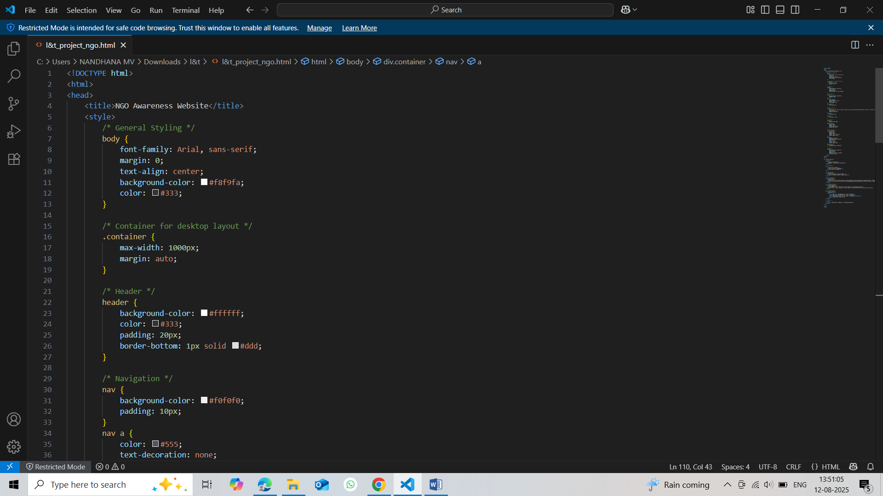

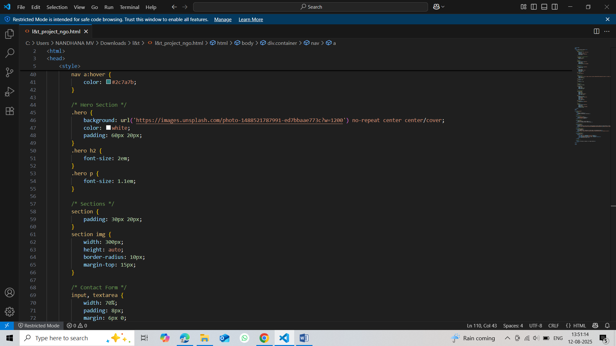

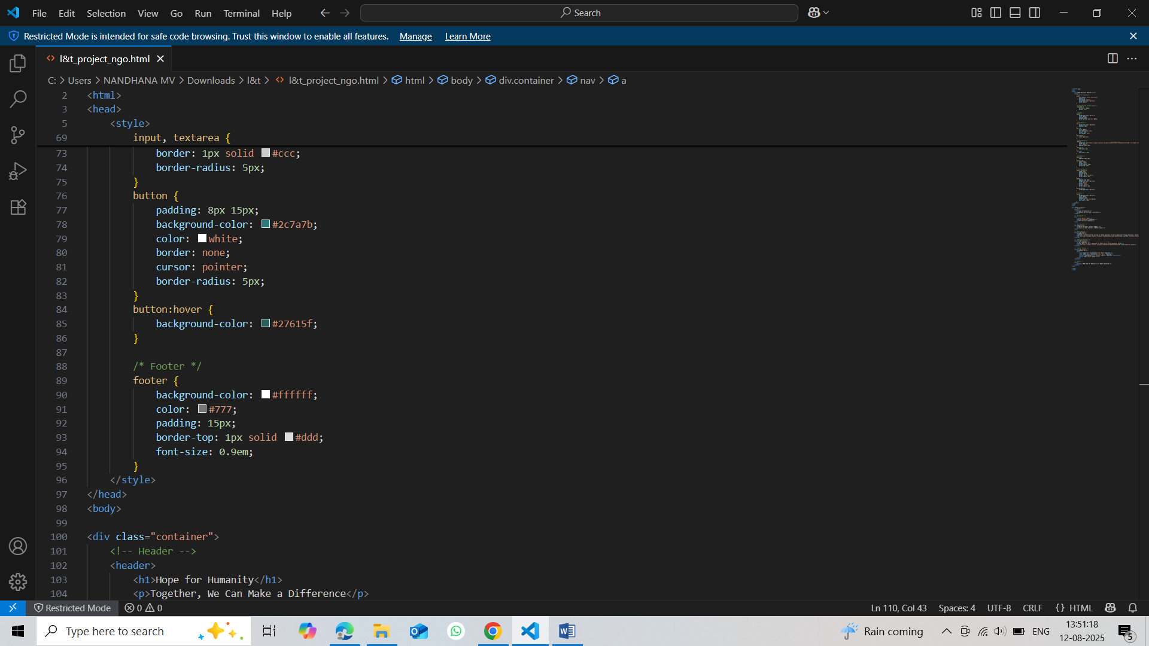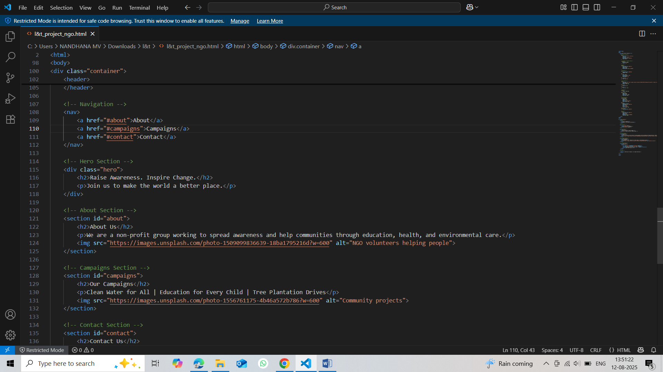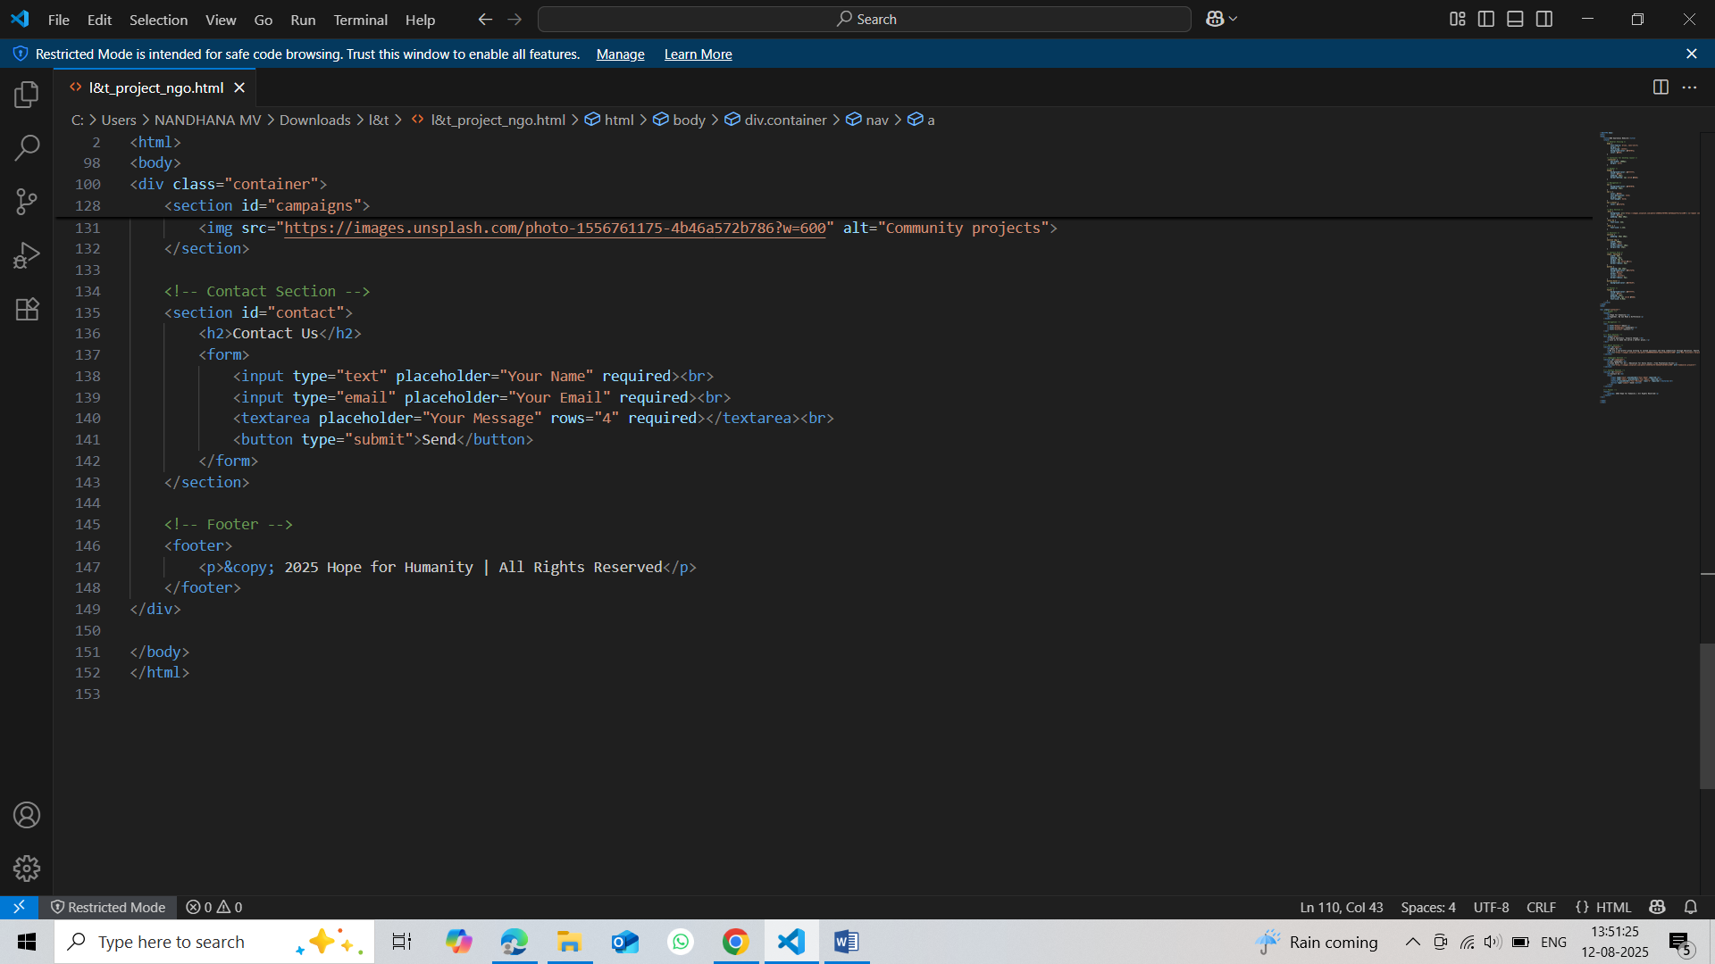

**13. Screenshots of Final Output**

*NGO awareness website* **:-**

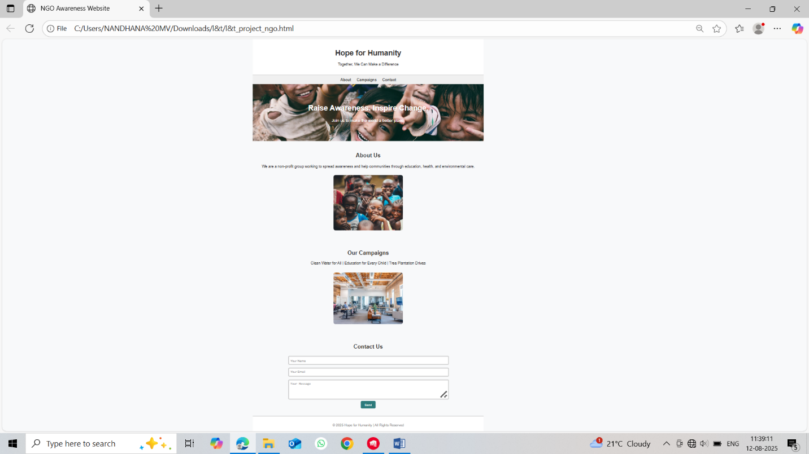

*online magazine layout:-*

**14. Conclusion**

Summarize your project & learning:

the NGO awareness website and the online magazine layout are simple yet powerful tools to share information and create awareness. The NGO website helps people understand causes, events, and ways to contribute .they can inspire more people to get involved and make a positive change.

**15. References**

* L&T LMS : https://learn.lntedutech.com/Landing/MyCourse